HARVELELECTRIC ELECTRONIC STORE

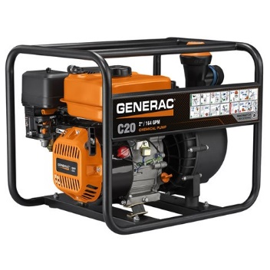

4.5KVA Sumec Firman Key Start Generator

Brand: [Sumec](https://www.jumia.com.ng/sumec/)

**Price: $5000**

Was ~~$6500~~ 54%

+ shipping only for V.V.I.P clients.

## **Product details**

AC Output 220v DC Output 12V/8.3A Phase No. Single Phase Engine SPE200E, Max6.5HP,4-stroke single cylinder, OHV, air cooled Alternator Brush, self exciting, synchronous,2-pole,100% Copper Enameled Wire Starting System Recoil/Electric Fuel Tank Capacity 15L Fuel Petrol Run Time per Tankful, Low Oil Warning System. Sumec Firman 45kva 100%Copper is equipped with a low oil warning system. The low oil warning system continuously monitors the oil level in your generator’s crankcase, automatically shutting down the engine if oil level falls below safe limits. This can save your generator from serious engine damage, but always ensure oil is within safe limit before starting a generator. Even more features: Electric Starter with key, Fuel meter, Volt meter, Float, Carburetor Brush, Alternator Portability Kit with handle and wheels. Engine model: SPE 200E – 6.5hp 196cc Engine Battery: 12v, 7.5Ah. Power factor: 1Pilot Lamp indicates that your Sumec Firman generator is working properly. Fuel sediment cup: The fuel sediment cup prevents dirt and/or water from flowing from the fuel tank to the carburetor 14Hrs@50%Load

## **Specifications**

## **KEY FEATURES**

Key start

100%copper

Max. Rated 4.5kva

15liter Tank Oil

## **WHAT’S IN THE BOX**

Key

Tyre

Wheels

Handle

## **SPECIFICATIONS**

* **SKU**: SU477GP06T4RXNAFAMZ
* **Product Line**: Home Base Store
* **Model**: Spg3000
* **Production Country**: China
* **Weight (kg)**: 49
* **Color**: Yellow
* **Main Material**: 100%copper